ITRW 313 GitHub Documentation

Teamwork No: 11

**TEAM MEMBERS STUDENT GITHUB USERNAMES**

**NUMBERS**

|  |  |  |
| --- | --- | --- |
| **X.N. SIBIYA** | 28360583 | Xollie93 |
| **T. SIBUTHA** | 26906880 | stobermrdamn |
| **VV.Themba** | 27869849 | VVThemba |
| **C. SITHOLE** | 28051467 | techeraa |
| **J. SITTIG** | 27483533 | JakesTheProgrammer |
| **S. SIVAKUMAR** | 26698218 | - |
| **M.M. SKOSANA** | 28182197 | mbalz10 |
| **R. SMALL** | 27027228 | Ruan0507 |
| **N. SMITH** | 27961192 | SmithNathaniel |
| **R. SNYMAN** | 24227463 | RuanSnyman123 |

Table of Contents

Problem Statement 3

Diagrams 3

Planning 4

End-user guide 4

# Problem Statement

The NWU cafe requests a new way of making sure that every customer is satisfied, even without the actual face to face interaction with a cashier at the Cafe. The expert system required is to have a question and response function between it and the user, which enables the user to enter the required product into the system interface in a response will be made by the system during interaction. [ Done by: TK Sibutha]

Our objective is to design a state machine for a soft drink machine that accepts quarters and nickels. This machine will accept payments (R5, R2, R1, c50, c20, and c10). After a payment has been made, options of items with prices will be given. After an item has been purchased and there is change, it will be calculated and returned. The different state spaces that happen during a purchase of an item will be represented by a finite state diagram. [Done by: Xolile Sibiya ]

# Diagrams

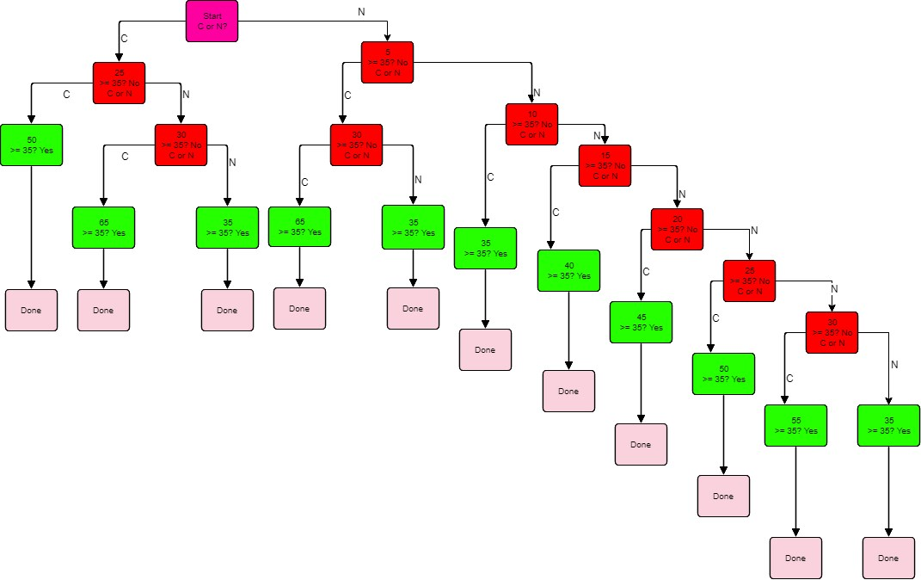

By: Chicko Sithole

# Planning

Our planning for this assignment consists of, one meeting, communication on a WhatsApp group and on the Efundi forum.

Our initial meeting was to establish who was in our ten person group. Everyone’s information was added and a WhatsApp group was created by Anjana Sivakumar. All initial communication was sent on this group.

We decided that Ruan Small would create the repository on GitHub and start the initial Finite State Machine clips code.

After the initial clips code was uploaded on the GitHub repository, it was decided to let all students add their GitHub usernames to the Efundi forum. After a few weeks of inactivity, working commenced again with adding the users to GitHub, only 6 out of the 10 members gave their usernames and was added to the GitHub.

New updates regarding the Vending Machine was given by the lecturer on the 17th April 2018. These updates were coded into the program during the week of the 10th May towards the 15th May 2018.

All documentation was to be finalized on the 15th of May 2018, so that it could be added to GitHub.

By: Jaco Sittig

# End-user guide

* The user must use the Clips IDE to run this Finite State vending Machine program.
* In Clips use the *Environment* tab and choose the option *Load Constructs* to select the clp file that is provided.
* Please remember to type into Clips, after the constructs are loaded in, (reset) and then (run) to compile and run the Vending Machine program.

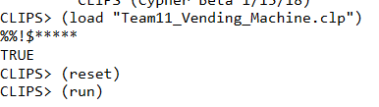

* The program will ask the user a series of questions consisting of asking what item to choose and also what amount to be entered.
* 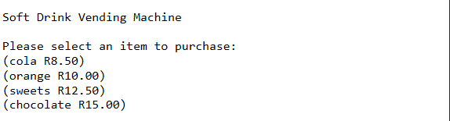
* When the amount has been entered, the program will display the user’s amount of change.
* The Finite State vending Machine accepts payments of R5, R2, R1, c50, c20, and c10.
* 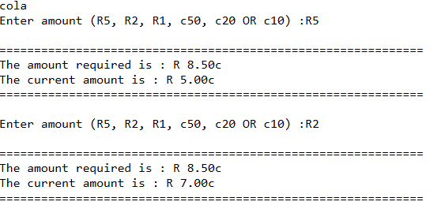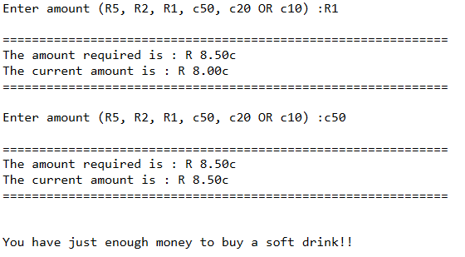
* The Finite State vending Machine adds up all the payments and gives the user a choice of items.

By: Ruan Small and Nathaniel Smith